Project Summary
Harrison Feldman
Student Number: 102100326
Course Code: COS30018
Project B - Stock Price Prediction System

Contents
1. Introduction 2
2. Overall System Architecture 2
2.1 Data Input and Data Preprocessing: 2
2.2 Model Training and Parameter Tuning: 3
2.3 High level compilation and prediction 4
3. Implemented Data Processing Techniques 4
3.1 Handling Missing Data 4
3.2 Normalization/Standardization 4
3.3 Sequence Generation for LSTM 4
3.4 Train-Test Split 5
4. Experimented Machine Learning Techniques 5
4.1 ARIMA Model 5
4.2 RNN Model 5
4.2.1 Key Findings: 6
4.2.2 Final Model Configuration: 6
6. Demonstration of System (Scenarios/Examples) 7
6.1 Example 1 – Single Day Prediction 7
6.2 Example 2 – Multistep/Multivariable Prediction 7
6.3 Example 3 – Ensemble Approach 8
7. Critical Analysis of Implementation 9
Strengths 9
Weaknesses 9
8. Conclusion 9

1. Introduction
The project will develop a predictive model using a neural network that predicts values from a dataset displaying linear and nonlinear trends. This was followed by the use of an ensemble approach, which would combine the strengths of ARIMA and LSTM in capturing linear and nonlinear trends, respectively.
In early development of the project, I worked on simplifying and improving the methods for data fetching and processing with multiple parameters for enhancing the data. The latter part of the project focussing on the model implementation, layer design and the multistep/multivariable problem.
It followed Python in implementation, with statsmodels being the main library for the ARIMA and TensorFlow/Keras for the LSTM model. The different sets of configuration parameters for ARIMA were tried, and data preprocessing was performed in order to get clean and usable data. This report is meant to give a summary of the approach taken, challenges faced, and final outcomes of the project.

2. Overall System Architecture
The system architecture for this project consists of the following components:

Data Input and Data Preprocessing:
The time series forecasting is performed based on some financial dataset loaded into the system. This dataset will hold historical data points of a given stock such as the Open, Close, High, Low, Volume and Adjusted Close of a given day. Cleaning and processing are done to turn this into a proper format that machine learning models can work with. The missing values are cleaned, and some transformation like differencing is done to make the time series stationary. This is handled by the load_data and load_data_multistep functions that exist within task2.py and task5.py respectively.
The parameters for these functions are:
- Ticker (string/Dataframe) – The stock name to be loaded from Yahoo Finance. Alternatively, a dataframe can be passed into this variable to bypass re-fetching the data from Yahoo Finance.
- n_steps (int): the historical sequence length (i.e. window size) used to predict, default is 50.
- scale (bool): whether to scale prices from 0 to 1, default is True.
- shuffle (bool): whether to shuffle the dataset (both training & testing), default is True.
- lookup_step (int): the future lookup step to predict, default is 1 (e.g. next day)
- split_by_date (bool): whether we split the dataset into training/testing by date, setting it to False will split datasets in a random way.
- split_by_ratio (float): ratio for test data, default is 0.2 (20% testing data)
- feature_columns (list<string>): the list of features to use to feed into the model, default is everything grabbed from yfinance (Yahoo Finance)
- data_start (date): The start date to fetch data between
- data_end (date): The end date to fetch data between
Additionally load_data_multistep includes:
- k_days (int) – The number of days used to target for future predictions.

The structure of these load_data and load_data_multistep functions are as follows.
  - Fetch the data if not directly passed in.
  - Assure all feature columns are included in the dataframe.
  - Scale each column of data to fit between 0 and 1.
  - Fetch the future/target values of each row by either shifting the data by the lookup_step or by taking a range or future values determined by k_days.
  - Clean any rows with NaN values.
  - Produce a set of sequences to train the data with.
  - Fetch and format the final sequence (to be used as the final prediction).
  - Format the sequences and targets into x and y values respectively.
  - Split the data into training and test data, using the split_by_date and split_by_ratio parameters as a means of bisection.
  - Format the output of the function.

Model Training and Parameter Tuning:
ARIMA and DL models are trained independently with different configurations. For ARIMA, parameters like p, d, and q are optimized. For LSTM, we optimize layers, neurons, and epochs to achieve the best performance.’
The DL model creation is achieved in the create_custom_model and create_custom_model_multistep functions from task4.py and task5.py respectively. These functions take in:
- Sequence length – A factual number of sequences used.
- Feature length – The number of columns used.
- Layers – A list of layer details including the layer type and layer size.

Both of these functions produce a model with an input layer based on the shape of the sequences and features length. Then a hidden layer and dropout layer is added based on the specifications in the Layers parameter. Finally, a Dense layer is added, and the model is compiled.
It’s worth noting that in create_custom_model the output layer contains only a single node while create_custom_model_multistep provides a model whose output layer size depends on the number of future predictions (k_days) that the user requires.

High level compilation and prediction
This stage incorporates the previous functions, putting everything together and producing a final output. Here we define the layers that will be used, the data to be fetched and the model(s) to be used. The final output can either look like a plot comparing the predicted vs. actual values or a single value predicting an outcome that is yet to have occurred (in the future).

3. Implemented Data Processing Techniques
The present step in data processing is important because it ensures that the raw input data will be good enough to be used for model training and making predictions. Proper preparation of data greatly enhances the performance of the models, especially in time series forecasting where trends, seasonality, and patterns need to be preserved. Specific details of the techniques implemented are given below:

3.1 Handling Missing Data
Managing missing data is critical for ensuring data quality in time series. In this project, if missing, null or NaN is to be found, an error is to be thrown to maintain the integrity of the dataset. This strict approach ensures that every stage in the process is rigid and will not cause a future stage to break.

3.2 Normalization/Standardization
Normalization of the dataset was necessary, using MinMax scaling to ensure that the data fed into the model is between the values of 0 and 1.
Normalizing helps avoid huge scale value dominance in the training process and aids in the working of finding patterns for neural networks. This step will be more relevant in those models, such as LSTM, where activation functions are used that are sensitive to the scale of the input.

3.3 Sequence Generation for LSTM
In the case of LSTM models, generating sequences is very crucial for maintaining the time-dependent nature of the data. This can be reflected in the following code, which shows the preparation of sequences using a sliding window approach.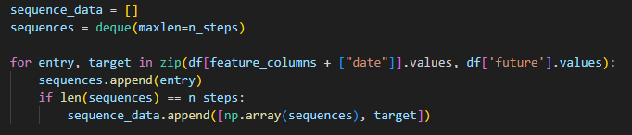
Here, a deque with a maximum length of n_steps is used to create rolling sequences of past data, where each line of data has a future target value it will try to predict. When a full sequence has been built up, it is appended to the sequence_data for the final training and testing.

3.4 Train-Test Split
In time series forecasting, it’s crucial to respect the sequential nature of data. As noted before the data can be split by either a ratio, a specific date or randomly where the earlier part chronologically can be used for training and the later part for testing.

4. Experimented Machine Learning Techniques

4.1 ARIMA Model
ARIMA is a linear model and is based on the relationship between the observations at various times. In this project, we conducted experiments with different parameters of the ARIMA model:
- p (autoregressive part): Number of lag observations.
- d (differencing): Degree of differencing to make the series stationary.
- q (moving average): Size of the moving average window.
Testing included multiple configurations of the ARIMA model in order to identify the best parameters of the model. All the combinations of the listed parameters were checked in order to see their influence on the predictive performance of the model.
The best performance was obtained for P = 2, D = 0, and Q = 0, for which the forecasted value is 95.97. Although this forecast is higher than the actual final value of 87.93, this configuration outperformed other models, so the fit is fairly reasonable.

4.2 RNN Model
LSTM (Long Short-Term Memory) is a type of recurrent neural network (RNN) that is well-suited for learning sequential dependencies. Key hyperparameters experimented with include:
- Number of layers and neurons: Different architectures were tried by varying the number of layers and neurons per layer.
- Training Epochs: Training epochs were adjusted to ensure that the model did not overfit or underfit the data.
- Batch Size: Batch size was tuned to balance computation time and accuracy.
When experimenting on the RNN models, multiple hyperparameters where varied to see their effects on the final outcome. This included the number of hidden layers used, the size of these layers, experimenting with a hybrid of LSTM and GRU layers, number of epochs, batch sizes and lookup steps.

4.2.1 Key Findings:

Experiment 1: Model Parameters
Increasing the number of layers reduced model accuracy, possibly due to the introduction of too much noise, resulting in predictions that flattened toward average values.
Interestingly, increasing the size of the layer seemed to have no significant effect on the accuracy or shape of the prediction.

Experiment 2: Mixed LSTM and GRU Layers
Mixing LSTM and GRU layers showed no improvement over using one type of layer exclusively. The percentage of each type or the order in which they were used had little effect on accuracy.
Too many layers still degraded performance, regardless of the combination used.

Experiment 3: Batch Size and Epochs
Here a batch size of 128 and 25 epochs produced the most accurate results. While individually altering the number of epochs or the batch sizes seemed to have little impact, there was a clear degradation when training over too few epochs with too high a batch size.

Experiment 4: Lookup Step (Historical Data)
Increasing the lookup_step (the amount of historical data used for future predictions) caused the predicted shape to move further in the future relative to the actual data’s shape. Effectively delaying the projection of the actual data's shape onto the predicted values.

4.2.2 Final Model Configuration:
After reviewing the results, the best-performing configuration was:
Lookup Step: 10
Batch Size: 128
Epochs: 25
2 LSTM Layers: Each with size 20
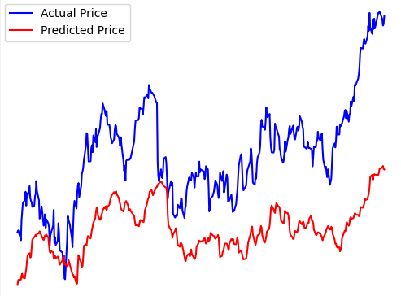
This final setup showed significant improvement over earlier experiments. While the shape of the prediction is highly precise, there’s still much more optimization that can be done to make the prediction more accurate, closer to the actual value of the real prices.

6. Demonstration of System (Scenarios/Examples)
This project contains multiple ways that a future stock price can be predicted. The following are some examples of predictions that were conducted.

6.1 Example 1 – Single Day Prediction
This first example is based on the simple case of predicting 1 day into the future, using the last 10 days as a training window. This chart shows the predictions of the model for the ticker “CBA.AX” over roughly 2 years.
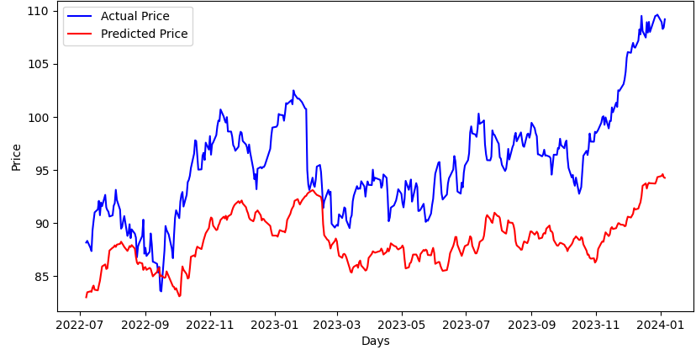

This chart shows that the predicted price matches the shape of the actual data well although the predicted values are significantly different to the actual price.

6.2 Example 2 – Multistep/Multivariable Prediction
This second example uses the multistep/multivariable approach to base its predictions. In this case the Open, Close, Volume, High, Low and Adjusted Close columns were used to predict the next 10 days.
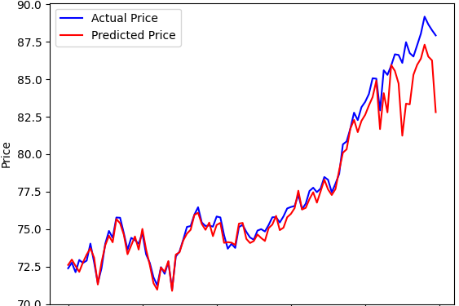

This prediction is extremely accurate for most parts of data. The prediction lags behind slightly but soon matches a very similar shape to the actual price.
The further into future, where less input is provided the prediction becomes more volatile and inaccurate. Although this prediction is still well within the rough amplitude of the real prediction.

6.3 Example 3 – Ensemble Approach
In this final example, a one-day ahead forecast ("tomorrow's forecast") is generated by combining the predictions from an RNN model and an ARIMA model. The approach here is to leverage the strengths of both models by averaging their outputs to create an ensemble prediction.
- Actual Value: $87.93
- LSTM Prediction: $82.81
- ARIMA Prediction: $109.14
- Ensemble Prediction: $95.97

Here the ensemble prediction shows a clear improvement compared to using the values of either the RNN or ARIMA models alone. There is however still a reasonable error that suggests that neither model properly captures the price dynamics on a small, day-to-day basis. To improve accuracy this approach could contain more models, averaging the values across each or possibly using a hyper model, passing in the values of these models’ outputs as its own inputs.
In summary, when employing an ensemble approach, it isn’t necessary to stick to a single rigid model.

7. Critical Analysis of Implementation
This projects implementation was successful. As with any project were improvements that can be made to improve effectiveness and efficiencies of the outcomes. However, at least at a high level this project shows that stock prediction using Intelligent Systems can be achieved.

Strengths
All the models presented were highly precise to the shape of the eventual actual data and its fluctuations over time. While these predicted values shouldn’t be used to predict the precise actual values of a stock, they can still be used to assess the trend that a stock is likely to follow.
This project also allows many parameters to alter the configurations of the models and the data. With this further experimentation can be easily achieved to improve the effectiveness of these models and functions.

Weaknesses
When using the ARIMA model I struggled to create data that can be show on an ongoing plot. Instead, I only used these values as a final ‘next day’ prediction. Tuning the parameters of this model was also computationally expensive and I worry that the values I eventually used were too low to show significant differences. The final approach, though effective could therefor be greatly improved by using further techniques such as weighted averaging, further models or more tuning of the ensemble models hyperparameters.
Handling time series data with high variance was challenging for both models as I was unsure whether spikes in data would ultimately change the overall precision of the predictions. It was therefore difficult to proceed further with certainty in whether long lookup ranges provided a more detailed and accurate prediction.

8. Conclusion
In this project I successfully implemented multiple methods and models for predicting stock prices using Intelligent systems. I was able to incorporate Recurrent Neural Networks, Long-Short-Term-Memory, Gated Recurrent Units and Autoregressive Integrated Moving Average models as well as enhancing my general understanding of python, data manipulation and other helpful libraries.
I experimented on different configurations for handling these models and the ultimate effect that different variables may provide to improve accuracy, precision and performance costs. While the final ensemble approach improved the overall accuracy of the predictions, there is still much room for further research into advanced ensembling techniques.
Ultimately this project demonstrates a plethora of opportunities in the world of machine learning to tackle complex problems such as time series forecasting.

